Technical Test: Game Design Document

Chapter Summary 1
6A Passageway / Mud Room 2
6A Closeup of Camo Coat 4
6A Camo Tile Puzzle 6
6A Closeup of Safe Clue 7
6A Closeup of Camera Case 8

Chapter Summary
In this chapter, Kate finds out that the underground secret passageway (from the shed floor in Ch5) leads to Jay’s dad’s hunting trophy room and rifle room. After unlocking the doors and exploring each of the rooms, she finds a cabinet of rifles that has an empty slot labeled “SlyHunter”, which is the same rifle used to kill Emma.

NOTE: you only do Passageway / Mud Room for the test. There is nothing about trophy room or rifle room in this document, don't worry about it

Time of Day: late evening

Main Actions

Open door to Hunting Trophy Room
- Open bin-> get stencil
- Get black camo paint
- Use stencil and paint on camo coat -> reveal two numbers for the safe lock
- Do camo tile puzzle on safe -> reveal two more numbers for the safe lock
- Find clue on scrap of paper -> figure out the order of the safe lock numbers
- Open the safe -> get blue, green, red, yellow arrows
- Observe camera case clue -> place arrows into door holes correctly -> door opens

Puzzle Summary
- Camouflage Tile Puzzle
- Observation Puzzles:
  - Camouflage numbers (open safe)
  - Camera case (arrows in door)

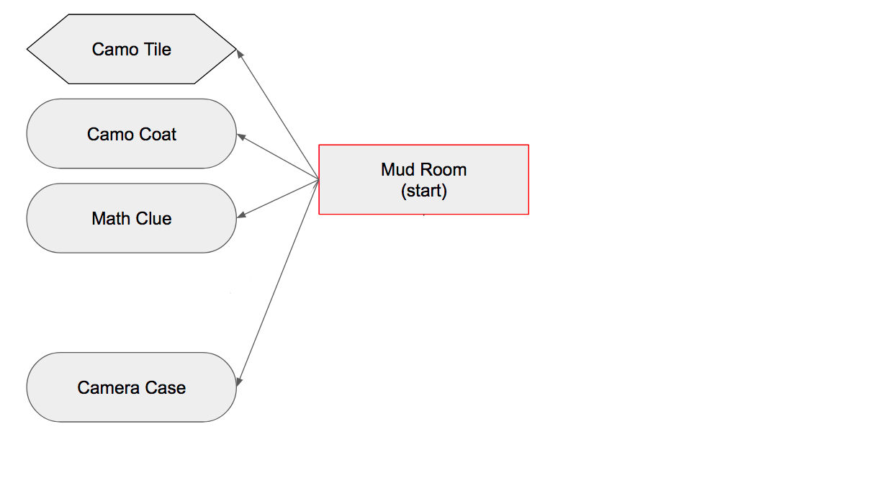
Scene Breakdown
- All One Scene

Inventory Item Slots:
- Camo paint
- Stencil
- Red arrow
- Blue arrow
- Green arrow
- Yellow arrow (x2)

6A Passageway / Mud Room

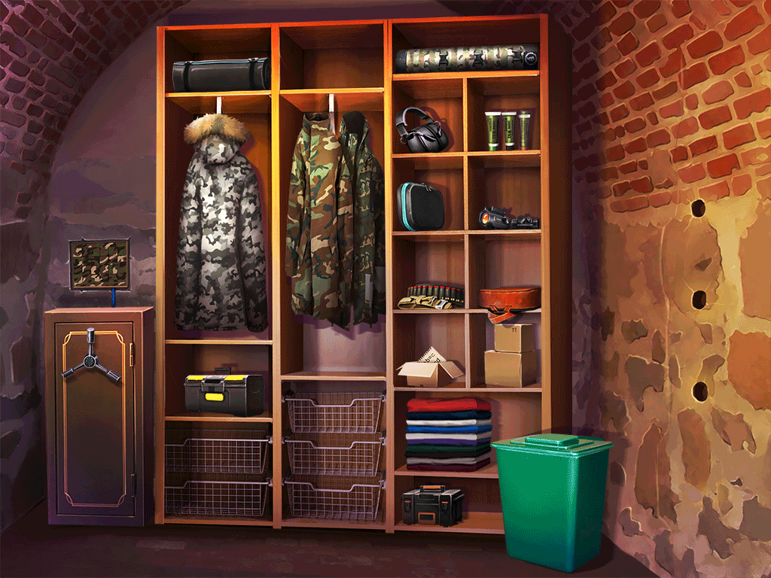
Summary
This scene is set inside the secret underground passageway that was accessed from the Shed. It looks like a sort of Mud Room where Frank stores his hunting gear.

Navigation
Door (once open) -> Hunting Trophy Room

Interactives
- Camo puzzle tiles -> go to Closeup of Camo Puzzle (note: use FloatingZoom prefab)
- Gray camo Coat on rack -> go to Closeup of Camo Coat
- Locked safe -> safe door opens on tap (note: normally we do some kind of a lock puzzle in such situation but we ommit it for this test)
  - Open safe contains crossbow and 4 colored arrows -> tap to pick up arrows (they go into different inventory slots).
    - Use one tap area for all arrows, but pick up one arrow for each tap so player must tap 4 times
- Green Bin
  - Tap to open, revealing stencil -> tap to pick up stencil
  - Tap again on green bin after taking stencil -> close it.
- Camera case on shelf -> go to Closeup of Camera Case (note: use FloatingZoom prefab)
- Camo paint tubes -> tap to pick up black paint
- Box with paper clue -> go to Closeup of Safe Clue (note: use FloatingZoom prefab)
- Brick door with 3 holes in it, arranged vertically
- If not opened yet:
  - Tap text CH6_WALL1
  - Use arrow on hole > arrow appears in hole
  - Tap arrow in hole -> take arrow back
  - Place all three arrows in correct order (green on top, blue in middle, red on bottom) -> door opens
- If opened -> show text CH6_TESTEND (note: normally door leads to another room but we ommit it for this test)
- Other miscellaneous tap text items:
- Crossbow -> CH6_CROSSBOW
- Green camouflage coats -> CH6_GREEN_COATS
- Ammo belt -> CH6_AMMO
- Either black box that doesn’t open -> CH6_CASE

6A Closeup of Camo Coat
Zoom Type Full screen (note: you can implement it as a separate room if you want to)

Navigation Back Button to Mud Room

Summary
This closeup appears when the player taps the gray coat on the rack. It shows the back of one of the coats. The player has to use the paint and stencil to alter the camouflage marks, revealing two numbers that are needed for the safe lock.

Interaction
Here’s how the coat looks at first:
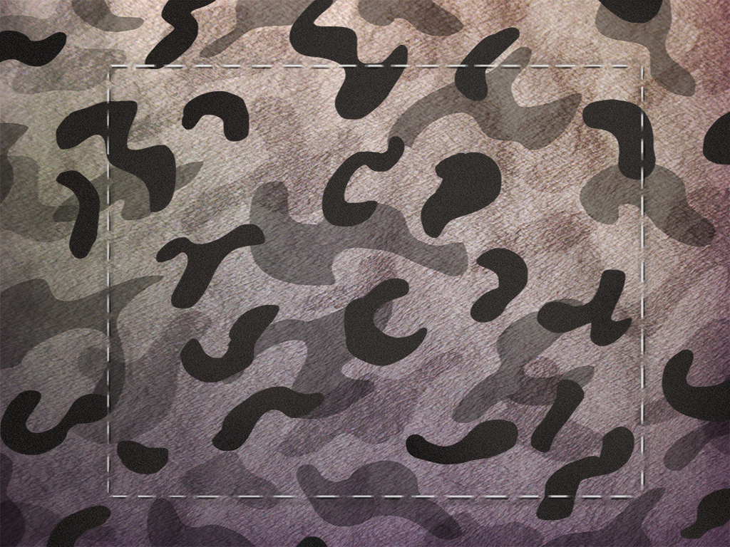
Tapping the coat in this state -> Tap text CH6_CAMO_COAT1

If the player uses the stencil on the coat, the stencil will get layered on top of the coat, like this:
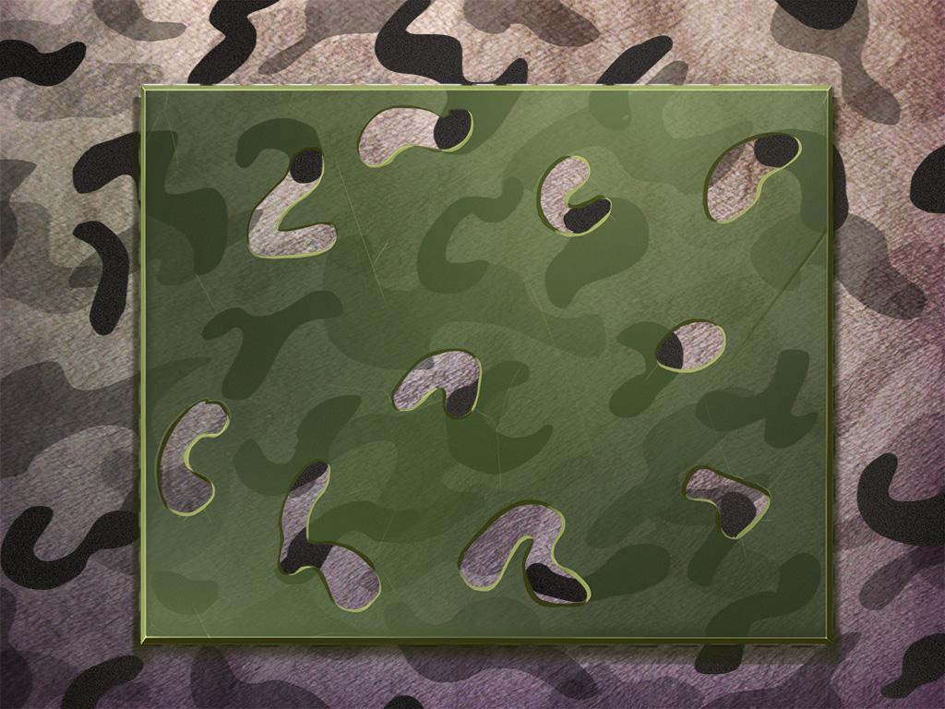
Tapping the coat or stencil in this state -> Tap text CH6_CAMO_COAT2

If the player then uses the black paint on the stencil, they’ll see the holes in the stencil get filled in with black paint, like this:
Show animation of using tube (note: the best way to do animations is to create an object with spriteRenderer of the tube with the FSM on it and use iTweenMove and iTweenRotate blocks to create a simple animation of using the tube)
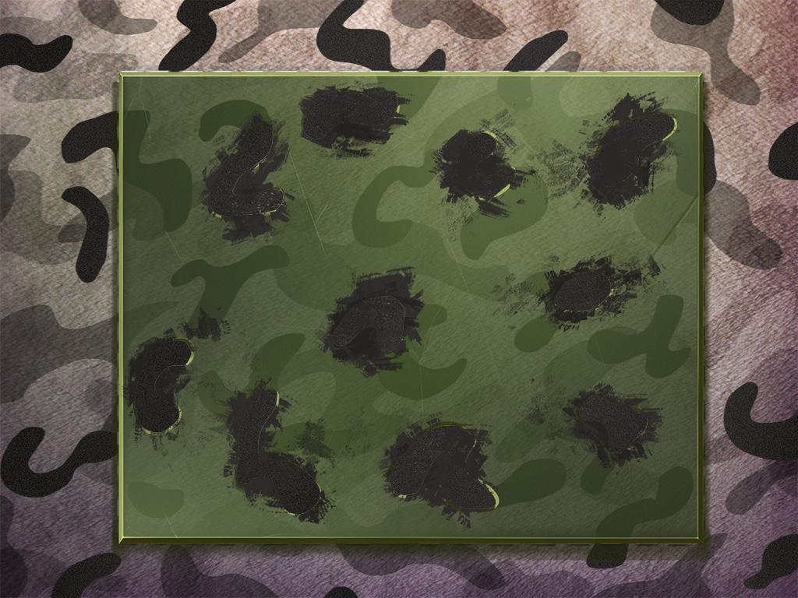

If they tap again, then the stencil will be removed from the coat, now with the black paint marks on it, like this:
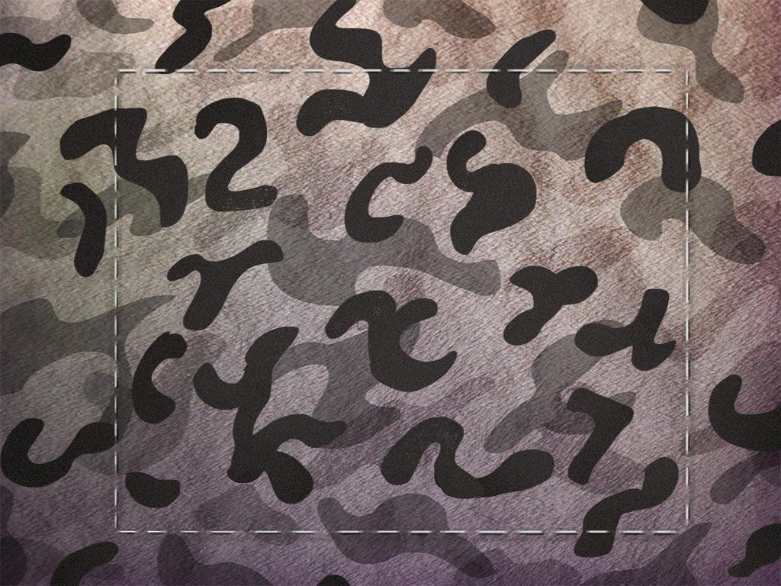
Tapping on the coat in this state -> CH6_CAMO_COAT3

If the player looks carefully at the coat, they’ll see that two numbers have been revealed in the pattern.
The numbers are 2 and 7.

6A Camo Tile Puzzle
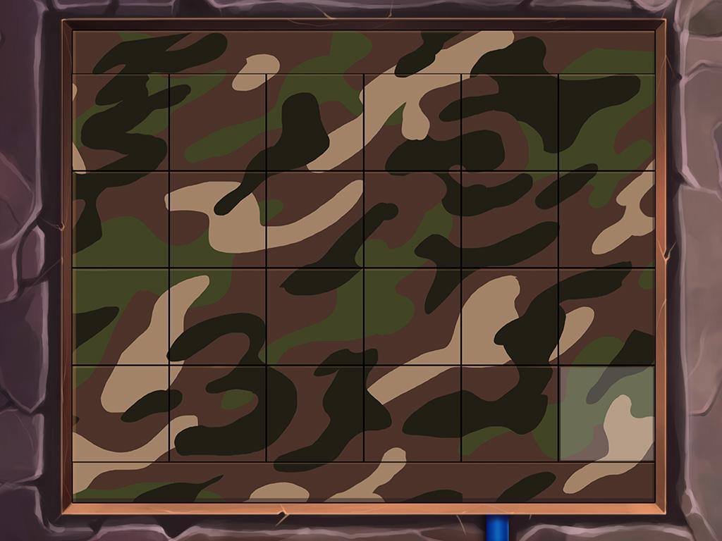
Summary
This is a full screen puzzle that shows a closeup of the grid of camouflage tiles that are on the upper part of the locked safe. The player has to arrange the tiles correctly to reveal two hidden numbers.
IMPORTANT NOTE: Please implement CamoTilePuzzle as a separate room. Use E19_PuzzleUICanvas prefab to show buttons (just drag this prefab as a child of the room). It should automatically handle navigation, skipping, and restarting (you should implement a ResetPuzzle() method in your puzzle controller script). Well... you have to also drag your PuzzleController component (see IMPORTANT_NOTE2 below) to the E19_PuzzleUICanvas inspector, and E19_PuzzleUICanvas to the PuzzleController inspector. Sorry for that... this is how we do it.
IMPORTANT NOTE2: Your script MUST inherits from the PuzzleController class. You can override methods of this class to implement a behaviour for skip, reset, activate, win.
IMPORTANT NOTE3: We always have an FSM to handle a “won” event of the puzzle. Inside it you have to add star animation and then the after-win-behaviour (for reference see the DoorLockBackground object and its FSM in the exampleChapterScene).
Navigation
Back Button to Mud Room

Skippable (Set cost to 0)
Puzzle can be skipped.
If puzzle skipped, swap all pieces to their correct position.

Starting State
The puzzle shows a 6x4 grid of tiles. The upper and lower edges of the puzzle are part of the background, they don’t change or move. These two edges provide visual clues that help the player figure out where to place the tiles. The tiles are all mixed up, in the wrong places.

Interaction
Tapping a tile highlights it. Tapping another tile makes the two tiles swap places. Tapping a tile that’s already selected will deselect it. (note: it is a very simple puzzle, just changing places of tiles, nothing fancy)

Solution
The solution looks like the mockup above. Once the puzzle is solved, there are 2 numbers that can be seen hidden in the pattern: a black 3, and a brown 5. These two numbers are part of the safe lock combination (note: as stated earlier we ommit the safe lock so the player gets no benefits from solving the Camo Tile Puzzle if he only plays your test game in his free time ;p)
Tapping puzzle after it’s solved -> CH6_CAMO_TILES

6A Closeup of Safe Clue
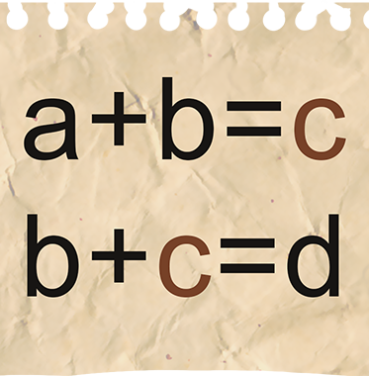
Zoom Type
- Floating on black background

Navigation
- Standard for FloatingZoom prefab

Summary
- This appears if the player taps the box with a paper sticking out of it on the shelf of the Mud Room.
- Tap anywhere on paper -> CH6_SAFE_CLUE
- This is the clue for the safe lock combination (3-2-5-7).
  - The black numbers the player gets from the camo coat and tile puzzle are 2, 3, and 7.
  - The brown number on the camo tile puzzle is 5.
  - Using those four numbers in the formulas here, you get
    - a=3, b=2, c=5, d=7

6A Closeup of Camera Case
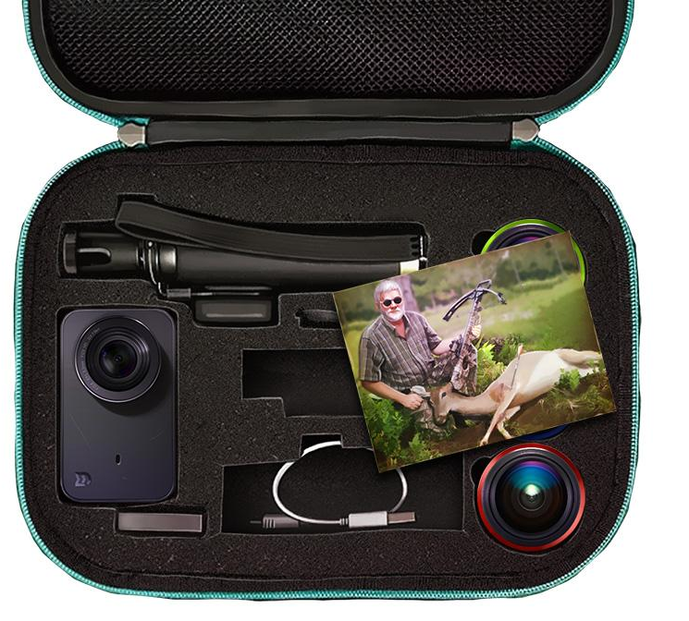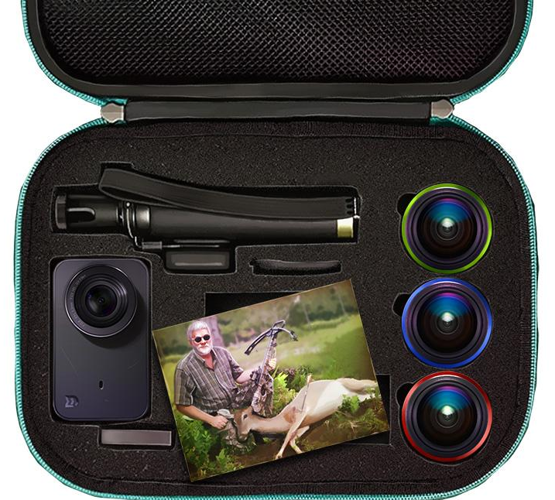
Zoom Type
- Floating on black background

Navigation
- Standard for FloatingZoom prefab

Summary
The open camera case shows a camera, three lenses, and a photo of Jay’s dad Frank posing with a deer that he killed with a crossbow.
- This closeup is a part of the observation puzzle for opening the brick secret door.
- Tapping the photo of Frank moves it to the position shown in the 2nd image below, revealing the 3 round camera lenses.
- The three lenses correspond to the three round holes in the door.
- The order of colors (green, blue, red) corresponds to the color order of the arrows that the player must place into the holes in the door.
- Tapping the photo of Frank after it’s moved -> CH6_PHOTO_FRANK
- Tapping a camera lens -> CH6_CAMERA_LENS
- Tapping the camera -> CH6_CAMERA

---------------------------------------------------------------------------------------------------
DECIDED TO OMIT IN TEST
-dialog
-find stars
-hints
-save system
-setting inventory icons (although it's easy anyway)

